ANAND INSTITUTE OF HIGHER TECHNOLOGY
Kazhipattur
Department of Information & Technology
Testimonials

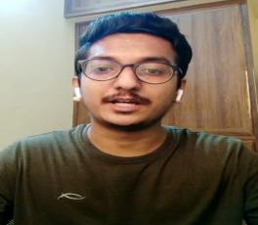
Kamalesh Murali, 2018 passed out,
Department of Information Technology
Placed in Tech. Mahendra
Hi all this is Kamalesh Murali from department of IT 2018 batch passed out from Anand INSTITUTE OF HIGHE TECHNOLOGY. I like to start with staffs. The staffs are very supportive, and they are very good at respective to clarify our doubt and they provide necessary notes next the management. The management is very supportive.
They encourage the students to participate the extra activities. They encourage us to move out of the college to participate other college events. They give permission to perform in hackathon which helps the students to make their programming knowledge improve the theoretical knowledge into applications.
In our college, Placements makes their effort to bring the companies. There are many numbers of companies came inside our campus. We are actively participated in the placements to make ourselves to better.
Students are very interested to place in companies.so the management are very helpful for making better in our professional carrier.

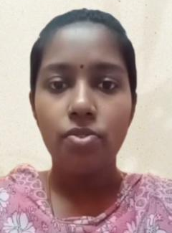
Karpaga Meena IV-year,
Department of Information Technology
Placed in Avasoft
Hi everyone, this is Karpaga Meena pursuing final year IT in AIHT.
I am very glad to tell that social lockdown period faculty members helped us to grab our placements so far, we attended the placements in companies cognizant, wipro, Infosys, avasoft in strategy.
They helped us to improve our technical knowledge by keeping placement classes and webinar which helped us to improve our technical knowledge.
we are thankful to our management our hod and our faculty members for this help stay home stay safe.

Aarthi (2015-2019),
Department of Information Technology
Placed in Infosys
Department of IT faculties give the full support to passing my bachelor’s degree, provide extra infrastructure to improve our technical knowledge. They provided as with good placement training and placement which helps me, and my friends too placed in good companies in the IT industry and passing higher education.
I resemble my beautiful thanks to department of IT and faculties for motivating me and my friends.
Thank you.

Swetha – IV
Department of Information Technology,
Placed in TCS,
We have well sophisticated classroom and laboratory , we have stationary, Xerox, canteen in our campus, so students need not to go out for any reason, we have well maintained bus facilities for day scholars.
In our department, all staffs are well knowledged and student friendly, our management provides government placement opportunity to the students. Our department students grab the opportunity and placed in companies. Our faculties arrange many workshop and seminars to the students for upgrade their knowledge.
Our students participated in many competitions. Students created many projects with the help of the faculty. I thank the management and department to give these much facilities to the students.
Thank you

